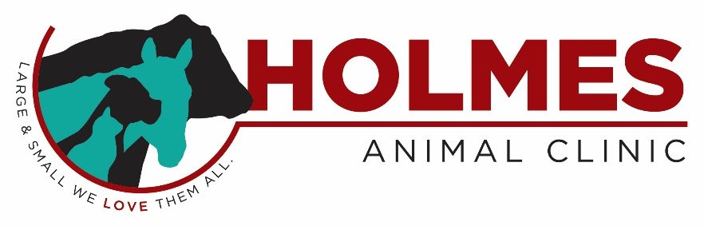

Associate Veterinarian Wanted
Holmes Animal Clinic is looking to add an enthusiastic, small animal or mixed animal veterinarian to join our family-owned, well-established, yet rapidly growing practice. Holmes Animal Clinic provides primary care, referral services and emergency services for Kossuth County and surrounding northern Iowa counties.
Currently, our practice is 90% companion animal and 10% Large Animal and Equine. The right candidate would have the opportunity to expand the large animal side of our business as well as serve our growing number of companion animal clients. Our newly renovated, 5,000 sq. ft. clinic includes a treatment area, surgery suite, in-door horse stock & stable, portable chute and boarding facility. We offer an in-house IDEXX diagnostic lab, companion animal laser, ultrasound, Shockwave, digital dental radiography, digital x-ray, in-house pharmacy, new endoscopy system w/ TCI scope, ultrasonic dental machine, MV1 Surgical Seal Electro Cautery, gas anesthesia, monitoring equipment, and more!
We are open to investing in technology and/or equipment if you practice a special interest we currently do not offer. Mentorship can be tailored as desired! Compensation is commensurate with experience and includes excellent health insurance, paid time off, continuing education allowance, and much more!

- Kossuth County has everything you need – affordable housing, world class health care, outstanding educational services, fine arts, a variety of recreation opportunities and a sense of community!
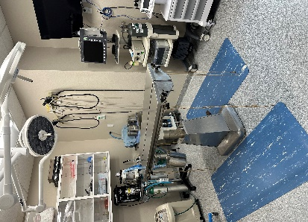
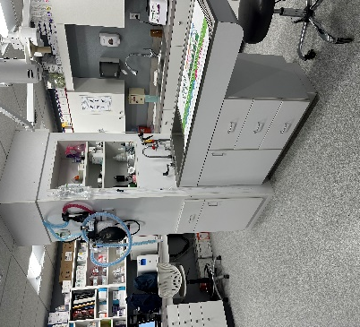
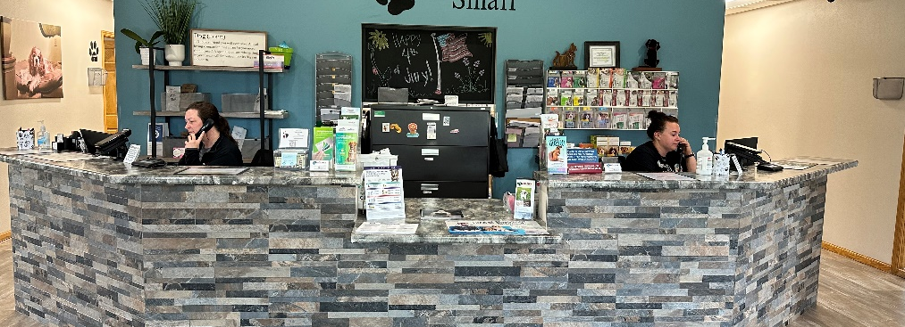
- Proximity to Iowa’s Great Lakes to our west and Clear Lake to our east!
Scan the QR code to learn more about our practice!

Feel

